**CELLMIA image processing software**

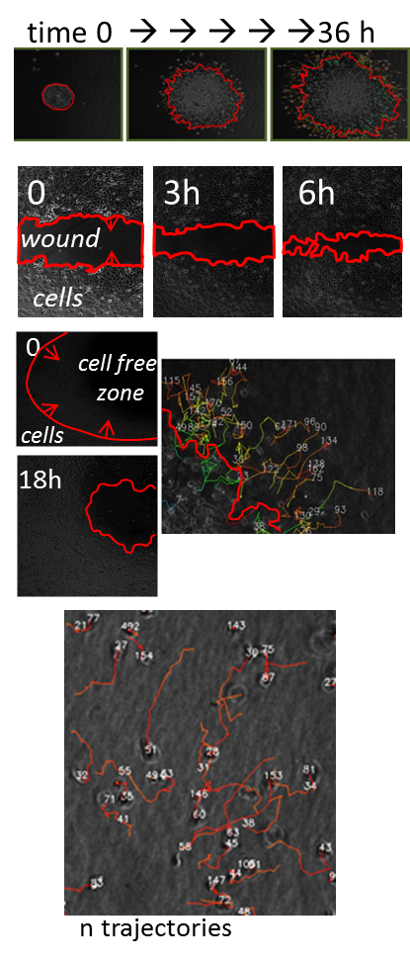**Info on CELLMIA software**

Commercial, not free nor open source (unfortunately).

Generated as a collaborative effort between VanTroys-Ampe at UGent Belgium and DciLabs (http://www.dcilabs.com/; here software is : ‘MIA’)

Designed for cell migration analysis imaged by phase contrast (with also handles fluorescent images): both of ‘more’ collective migration* and for individual cell tracking (only xyt, not xyzt) (see image).Both analysis are always simultaneously performed on an image MULTI-TIFF time sequence. (see figure)

*Collective migration= cell sheet migration, bulk cell migration: e.g. of a peripheral sheet in a well closing a central cell-free zone (cell exclusion zone assay type) or the bulk population formed by a spheroid.

Analysis is fully automatic; two algorithms (~image quality, contrast) with flexible parameter settings can be used.

Batch analysis is performed and output is stored in a specific folder/file structure generated by the software.

The sample folder is here the identifier (within each sample folder all files are named identical for all samples)

Output: one folder per sample (e.g. one imaged position in a well, one imaged position in the well of a multwell plate)

**Each Sample folder contains RESULTS folder**

Two txt file for each simultaneously performed analysis type.

**Cell Tracking Files**

Type .txt

File name e.g. 0001_mode1_z000_f000_tracking

Location

'results' folder

Description: Cell tracking data with an entry for each timepoint and cell in a timetrace

Output parameters (see table below)

**Cell Bulk Region Files**

Type .txt

File name e.g. 0001_mode1_z000_f000_bulkcell

Location

'results' folder

Description Bulk cell region statistics, with entry for each time point.

**Images**

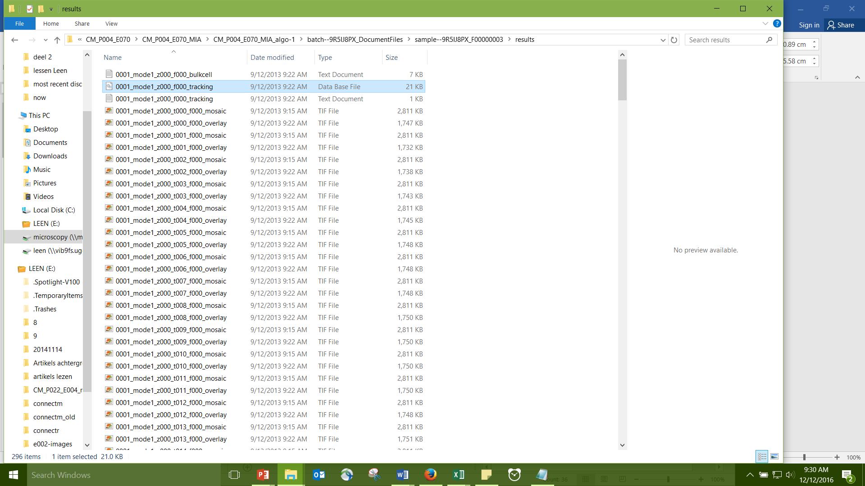In results folder: **raw images overlaid** with delineation of bulk cell area and with identified tracks; one image for each time point of the sequence (ext . overlay)

In separate folder (001) raw images (in results folder)

**Description of migration parameters**

**(see table)**

Posted data are example text files (tracking and bulk cell) on experiment in which breast cancer cell line MDA-MB-231 is treated with different doses of actin drug jasplakinolide.

Subsequent to CELLMIA analysis, the output is in our lab automatically read by CellMissy. We only pick up and store in CellMissy relational database:

For tracking: ID, Time index, x and y

For Bulk cell area: time, area

All migration features are computed and compared (over samples) by CellMissy

In CellMissy Experiment metadata is in part added by user, in part read from propriety metadata files of imaging software (Olympus) and CELLMIA.

I include experimental setup report for the posted experiment (generated by CellMissy).